Team 5 Course Registration System
Architecture Design Document
INFO 465 - Architecture Assignment
Repository: https://github.com/aghomofeunml-fr/info465_team5_registration_system.git
Prepared by: Eileena Doek, Michael Aghomo, Sinneh Bangura
Date: [6/30/2026]

Document purpose: This architecture document defines the proposed cloud infrastructure, application design, database schema, network architecture, security controls, testing approach, authentication roles, and team responsibilities for the Online Course Registration System. It is intended to serve as the technical blueprint for later infrastructure, database, and sprint implementation work.

1. Project Overview
The Online Course Registration System will provide students, instructors, and administrators with a browser-based interface for searching courses, registering for course sessions, viewing instructor schedules, and reviewing enrolled students in specific sessions. The system is designed as a three-layer web application with a presentation layer, an application/API layer, and a relational database layer.
The proposed architecture emphasizes maintainability, scalability, and security. The application will start as a small team project but is designed so it could later scale to handle more students, departments, courses, and registration periods.

2. Cloud Service Provider

2.1 Selected Provider: Amazon Web Services (AWS)
AWS is selected as the cloud provider because it offers a mature set of services for hosting web applications, managing relational databases, securing network resources, and monitoring system health. AWS also supports a pay-as-you-go model, which helps control cost for a student/team project while still allowing the system to scale if the course registration workload grows.
Factor | Justification
Cost | AWS allows small EC2 instances, managed database sizing, and storage to be scaled based on project needs. The team can begin with low-cost resources and increase capacity only if needed.
Scalability | Application servers can be placed behind an Application Load Balancer and scaled horizontally. Amazon RDS can be configured for larger instance classes and Multi-AZ availability.
Available Services | AWS provides EC2 for virtual servers, RDS PostgreSQL for the relational database, S3 for static assets/backups, VPC networking, IAM, Secrets Manager, CloudWatch, ACM, and Route 53.
Security | AWS supports private subnets, security groups, IAM least privilege, TLS certificates, encrypted RDS storage, and centralized logs/monitoring.

2.2 AWS Services Used
AWS Service | Purpose in Architecture
Amazon VPC | Creates an isolated network containing public, private application, and private database subnets.
Amazon EC2 | Hosts the Node.js/Express application servers in private subnets.
Application Load Balancer | Receives HTTPS traffic from users and routes it to the private application servers.
Amazon RDS for PostgreSQL | Managed relational database for users, courses, sessions, enrollments, and schedules.
Amazon S3 | Stores static assets, exported reports, and optional backup artifacts.
AWS Secrets Manager | Stores database credentials and API secrets outside of application source code.
Amazon CloudWatch | Collects logs, metrics, and alarms for application and infrastructure monitoring.
AWS IAM | Controls service permissions using least-privilege roles and policies.
AWS Certificate Manager | Provides TLS certificates for HTTPS access.
Route 53 | Optional DNS service if the team later connects a custom domain.

3. Application Design
Design Area | Decision and Definition
Programming Language | JavaScript for both the browser-based UI and the Node.js backend.
Runtime Environment | Node.js LTS runtime on Ubuntu Linux EC2 instances.
API Style | RESTful API using JSON request and response bodies.
Application Framework | None for the current UI prototype; browser-based HTML/CSS/JavaScript screens. A later sprint could migrate the UI to React if needed.
Middleware | Express.js for routing, request validation, error handling, and API middleware.
Data Access | Node PostgreSQL database driver or an ORM such as Prisma/Sequelize in a later sprint.
Deployment Model | Application servers run in private subnets behind an Application Load Balancer.

3.1 Presentation, Application, and Data Layers
Layer | Components | Responsibilities
Presentation Layer | Browser UI using HTML, CSS, and JavaScript screens. | The User facing part of the online course registration system. Includes browser-based screens that students, instructors, and administrators interact with. Main screens will include the home screen, course search, student registration, instructor schedule screen, and session enrollment screen.
Application Layer | Node.js + Express REST API running on EC2. | Contains the main business logic of the system. Receives request, applies system rules, communicates with the database, and returns a response to the user interface. Helps enforce role-based access rules. Receives browser requests, authenticates/authorizes users, validates inputs, applies registration rules, and communicates with the database.
Data Layer | Amazon RDS PostgreSQL database. | Designed to store and separate major entities into individual tables to reduce duplication and support third-normal form. Will not be directly exposed to users or the public internet. Stores normalized data for users, roles, students, instructors, departments, courses, terms, sessions, and enrollments.

3.2 Core REST API Endpoints
List of Core REST API endpoints, “routes” our application would use to send and receive data, this belongs to the application design.
Endpoint | Method | Purpose
/courses | GET | Return all courses or filter by query parameters such as department, instructor, or course number.
/courses/{courseId} | GET | Return detailed information for a selected course, including credits, modality, and prerequisites.
/sessions | GET | Return available course sessions for a term or course.
/sessions/{sessionId} | GET | Return detailed information for a specific course session.
/students/login | POST | Submit student login credentials and begin a student session.
/students/{studentId}/enrollments | GET | Show the sessions in which a student is currently enrolled.
/enrollments | POST | Register a student for a course session after checking duplicate enrollment and capacity.
/enrollments/{enrollmentId} | DELETE | Drop or withdraw a student from a registered session.
/instructors/login | POST | Submit instructor login credentials and begin an instructor session.
/instructors/{instructorId}/schedule | GET | Return the instructor’s assigned teaching schedule.
/sessions/{sessionId}/enrollment | GET | Return the list of students enrolled in a selected session for authorized users.

3.3 Primary Function Flow: Student Registers for a Course
This flow shows how a student’s request moves from the browser-based user interface to the backend application layer, into the PostgreSQL database and then back to the user to the user interface with either a success or error message.
1. The student opens the Student Registration screen and selects a course session to register for. (Presentation Layer). After logging in, the student can view their currently enrolled sessions and browse or select an available course session. The screen displays important session details such as course number, course title, instructor, modality, meeting time, available seats, and maximum enrollment
1.1. The student clicks the “Register” button for a selected course session. The browser collects the required values, including the student ID from the logged-in user session and the selected session ID from the course listing. The frontend in the user session and the selected session ID from the course listing. The frontend does not directly update the database. Instead, it sends the request to the backend API so that business rules can be validated securely.
2. The browser sends a POST request to /enrollments with the student ID and session ID.
{
"studentId": 1025,
"sessionId": 3301
}
3. The Express API receives the POST /enrollments request and confirms that the logged-in user has the Student role. It also checks that the submitted student ID and session ID are present, properly formatted, and match existing records in the Students and Sessions tables.
4. The API checks the Enrollments table to see if the student is already actively enrolled in the selected session. If an active record already exists for the same student and session, the API stops the request and returns a duplicate-registration error.
5. If the student is not already enrolled, the API checks the session capacity. It counts the active enrollments for the selected session and compares that number to the session’s max_enrollment value. If the course is full, the API returns an enrollment-limit error.
6. If all checks pass, the API creates a new record in the Enrollments table with the student ID, session ID, enrollment date, and status set to active.
7. PostgreSQL commits the transaction and confirms that the enrollment record was saved successfully. If any step fails, the transaction is rolled back to prevent incomplete or incorrect data.
8. The API returns a success response to the browser, and the UI updates the student’s enrolled sessions list.

3.4 System Architecture Diagram
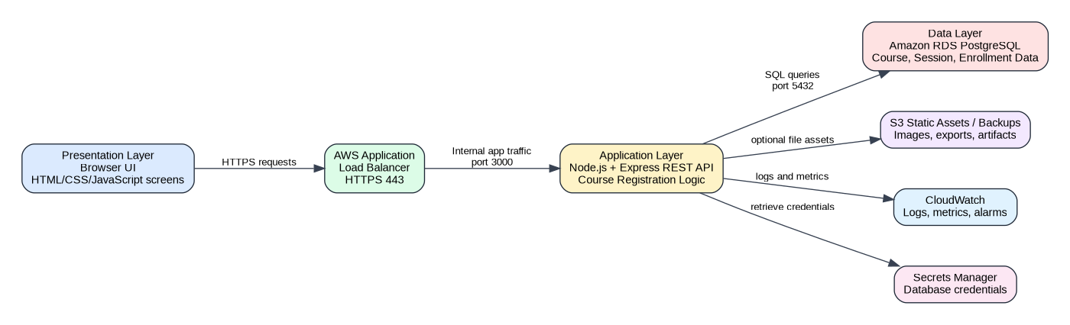
Figure 1. System architecture showing how the browser UI, application layer, and database layer interact.

4. Operating System and Virtual Servers

4.1 Operating System Selection
Ubuntu Server LTS is selected for the EC2 virtual servers. Linux is cost-effective, widely used for Node.js applications, well supported by AWS, and has strong package management and security-update practices. Ubuntu LTS provides a stable base for production-like sprint work while remaining accessible for a student development team.

4.2 Server Configuration
The system will use two application servers for redundancy and high availability. Each application server will run the Node.js and Express.js backend API in a private application subnet. The servers will be deployed across separate availability zones so the application can continue operating if one server or availability zone becomes unavailable.
Operating System Selection: Ubuntu Server LTS. Ubuntu Server LTS is selected because it is lightweight, stable, cost-effective, and commonly used for Node.js web applications. It supports Node.js, npm, Express.js, and standard deployment tools without requiring Windows Server licensing. Ubuntu also works well with AWS EC2, security updates, SSH administration, and common web application monitoring tools.

Component | Instance / Service | CPU | Memory | Storage | Operating System | Network Placement | Purpose
Application Server A | Amazon EC2 t3.small | 2 vCPU | 2 GB RAM | 30 GB gp3 EBS | Ubuntu Server LTS | Private App Subnet A | Runs the Node.js/Express API in the first availability zone.
Application Server B | Amazon EC2 t3.small | 2 vCPU | 2 GB RAM | 30 GB gp3 EBS | Ubuntu Server LTS | Private App Subnet B | Provides redundancy by running the same backend API in a second availability zone.
Load Balancer | AWS Application Load Balancer | Managed by AWS | Managed by AWS | Not applicable | Managed AWS service | Public Subnets A and B | Routes HTTPS traffic from users to healthy private application servers.
Database | Amazon RDS PostgreSQL db.t3.micro for development; db.t3.small or Multi-AZ for production-like design | 2 vCPU for db.t3.micro/db.t3.small class | 1 GB RAM for db.t3.micro or 2 GB RAM for db.t3.small | 20-50 GB allocated database storage | Managed PostgreSQL | Private Database Subnets A and B | Stores users, students, instructors, courses, sessions, and enrollments.
Object Storage | Amazon S3 bucket | Managed by AWS | Managed by AWS | Scales as needed | Managed AWS service | Private access through IAM/bucket policies | Stores optional static assets, exports, reports, and backup artifacts.

5. Database Design

5.1 Database Management System
The database management system will be PostgreSQL hosted on Amazon RDS. PostgreSQL is a strong fit because it supports relational integrity, foreign keys, constraints, transactions, indexes, and SQL queries needed for course search, enrollment checks, and reporting.

5.2 Entity-Relationship Diagram
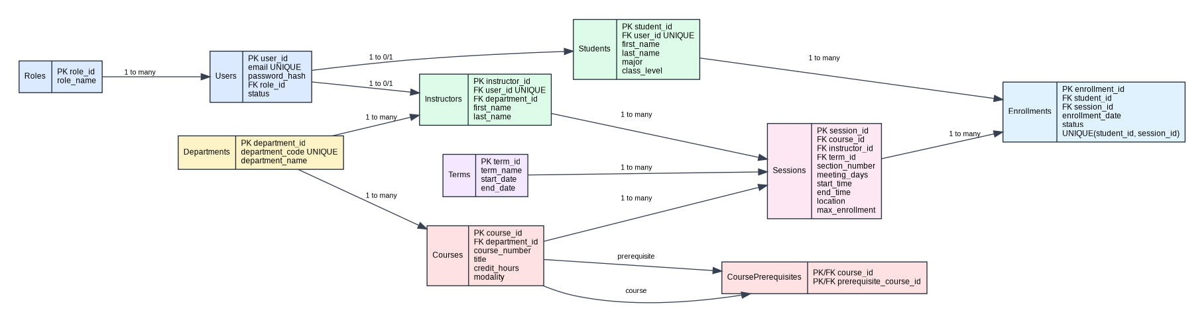
Figure 2. ER diagram for the Online Course Registration System database.

5.3 Schema Summary and Third-Normal Form
Table | Primary Purpose | Key Relationships / Constraints
Roles | Stores role names such as Student, Instructor, and Administrator. | One role can be assigned to many users.
Users | Stores login account information. | Each user has one role. Email must be unique.
Students | Stores student-specific profile information. | One-to-one relationship with Users.
Instructors | Stores instructor-specific profile information. | One-to-one relationship with Users and many-to-one relationship with Departments.
Departments | Stores department codes and names. | One department has many courses and many instructors.
Courses | Stores catalog-level course details. | Many courses belong to one department. Course sessions are separate from catalog details.
CoursePrerequisites | Stores prerequisite relationships between courses. | Associative table prevents repeating prerequisite text in Courses.
Terms | Stores academic term information. | One term has many sessions.
Sessions | Stores each scheduled course offering. | Each session belongs to one course, one instructor, and one term.
Enrollments | Stores student registrations in sessions. | Unique constraint on student_id and session_id prevents duplicate registrations.

The schema supports third-normal form by separating account, student, instructor, department, course, session, term, and enrollment data into separate tables. Repeating groups are removed, non-key attributes depend on their table keys, and many-to-many relationships are handled through associative tables such as Enrollments and CoursePrerequisites.

6. Network Architecture and Security

6.1 Network Architecture Diagram
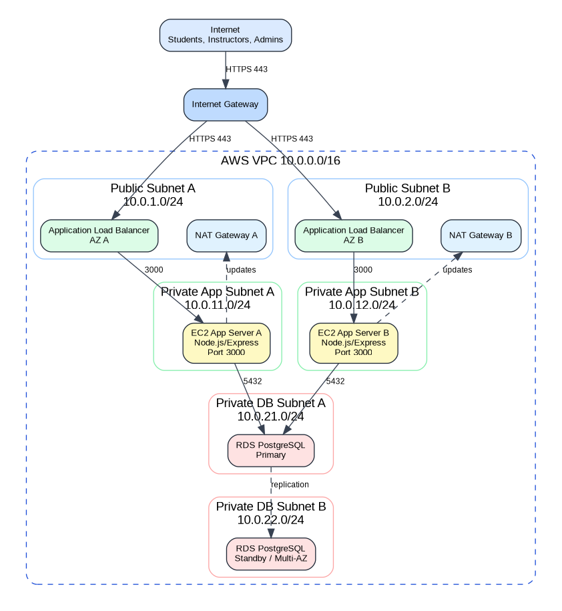
Figure 3. Network architecture with public/private subnets, VPC boundaries, firewalls, and redundant availability zones.

6.2 VPC and Subnet Design
Network Component | CIDR / Placement | Purpose
VPC | 10.0.0.0/16 | Isolated AWS network for the registration system.
Public Subnet A | 10.0.1.0/24 in AZ A | Hosts public load balancer interface and NAT Gateway.
Public Subnet B | 10.0.2.0/24 in AZ B | Provides redundant public network path in a second availability zone.
Private App Subnet A | 10.0.11.0/24 in AZ A | Hosts application server A. No direct public inbound access.
Private App Subnet B | 10.0.12.0/24 in AZ B | Hosts application server B for high availability.
Private DB Subnet A | 10.0.21.0/24 in AZ A | Hosts RDS primary database endpoint.
Private DB Subnet B | 10.0.22.0/24 in AZ B | Hosts RDS standby/subnet group placement for Multi-AZ resiliency.
Internet Gateway | Attached to VPC | Allows internet users to reach only the public load balancer.
NAT Gateway | Public subnets | Allows private servers to download patches/updates without exposing them directly to the internet.

6.3 Security Groups and Port Rules
Security Group | Inbound Rules | Outbound Rules
Load Balancer SG | TCP 443 from 0.0.0.0/0. Optional TCP 80 only to redirect to HTTPS. | TCP 3000 to Application Server SG.
Application Server SG | TCP 3000 from Load Balancer SG only. Optional SSH 22 only from approved admin IP, or prefer AWS Systems Manager instead of SSH. | TCP 5432 to Database SG. HTTPS 443 outbound for updates and AWS service access.
Database SG | TCP 5432 from Application Server SG only. | Default restricted outbound or database-required responses only.
Admin Access | Prefer AWS Systems Manager Session Manager. If SSH is used, restrict TCP 22 to approved administrator IPs only. | Administrative outbound access only as needed.

6.4 Additional Security Measures
- Use HTTPS/TLS through AWS Certificate Manager so credentials and registration actions are encrypted in transit.
- Store database passwords and other sensitive values in AWS Secrets Manager, not in source code or GitHub.
- Enable RDS encryption at rest and automated backups.
- Use IAM least-privilege roles for EC2, S3, CloudWatch, and database-related access.
- Log application errors and security-relevant events to CloudWatch.
- Validate and sanitize user input in the API layer to reduce injection and data quality risks.
- Use database constraints to enforce duplicate-registration prevention and referential integrity.

7. Testing and Quality Assurance Process
Testing Type | Sprint Approach
Unit Testing | Validate individual components such as course search filters, registration validation, duplicate enrollment checks, capacity checks, and input validation functions. JavaScript tests can be run with Jest.
Integration Testing | Test interaction between the browser UI, Express API routes, and PostgreSQL database. Example: a POST /enrollments request should insert an enrollment row and return the correct success or error response.
End-to-End Testing | Test complete user workflows from the browser, such as logging in, searching for a course, registering for a session, viewing a schedule, and viewing a session roster. Cypress or Playwright can be used in later sprints.
Regression Testing | Run previously passing test cases after each sprint change to ensure new changes do not break existing features.
Security Testing | Review authentication checks, authorization rules, input validation, dependency vulnerabilities, and secret exposure before merging major changes.
User Acceptance Testing | Have team members walk through student, instructor, and administrator scenarios and verify the UI is understandable and task-oriented.
Load Testing

8. Authentication and Authorization Process
Implementation of authentication and authorization is out of scope for this architecture assignment, but the system will be designed around clear roles and permissions. Future implementation can use session-based authentication or token-based authentication, with password hashes stored securely and role checks performed in the API layer.
Role | Expected Permissions
Student | Search courses, view course details, view enrolled sessions, register for available sessions, and drop registered sessions.
Instructor | Log in, view assigned sessions, and view enrollment rosters for sessions they teach.
Administrator | Manage users, courses, departments, sessions, enrollment limits, and view enrollment rosters across the system.
Guest / Public User | View the home page and optionally search publicly available course catalog information, depending on team requirements.

9. Team Responsibilities
Role | Team Member | Responsibility
Cloud Architect | Eileena Doek | Selected AWS services and described the cloud infrastructure.
Application Developer | Eileena Doek | Defined the application runtime, API endpoints, middleware, port configuration, and request flow.
Database Architect | Michael Aghomo | Designed the PostgreSQL schema, ER diagram, and third-normal form explanation.
Network Engineer | Michael Aghomo | Designed the VPC, subnets, security groups, firewall rules, and network diagram.
QA Analyst | Sinneh Bangura | Created the unit, integration, end-to-end, regression, and security testing plan.
Project Manager | Eileena Doek | Coordinated the final document, GitHub repository link, collaborator proof, and submission package.

10. GitHub Repository and Collaboration Proof
The team will use the following GitHub repository as the official collaboration platform for the project:
Repository URL: https://github.com/aghomofeunml-fr/info465_team5_registration_system.git

